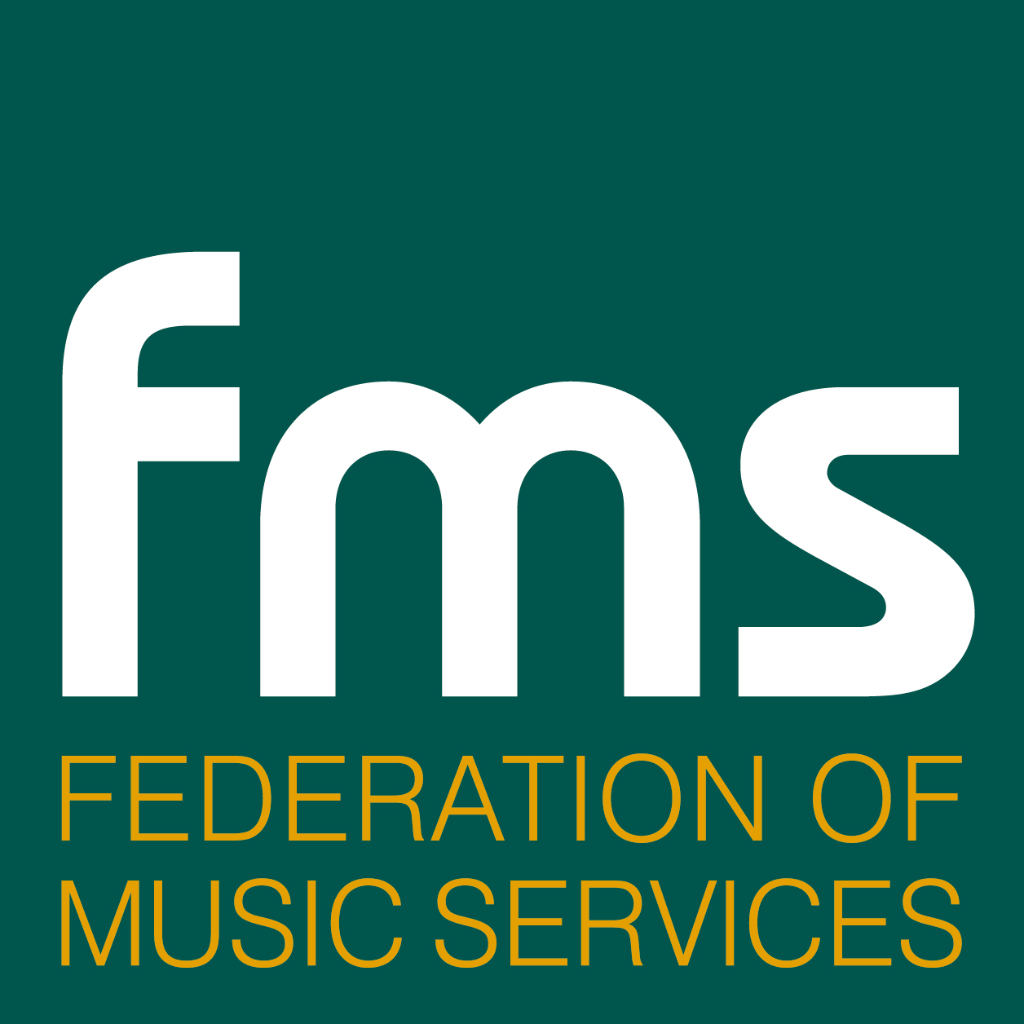

Release date: Immediate

Joint FMS/Sing Up Collaboration Celebrates with 3500
Young Performers at Birmingham’s Symphony Hall

A unique collaboration of 14 West Midlands Music Services, which form the National Sing up Project West Midlands Consortium, was rewarded with a successful Sing Up event held on Monday 26 January at Birmingham’s prestigious Symphony Hall.

The combined event involved over a 3500 KS1 and 2 young singers, and nearly 500 teachers and other adults as part of a huge CPD input, in two singing workshops led by vocal supremo, Lin Marsh, together with singing leaders from each of the authorities. Both workshops included specially written material by Lin Marsh and a versatile band which accompanied the pieces.

In the evening the Sing Up event culminated in a spectacular massed transition choir featuring 350 children from across the region; it was directed by the well known conductor, David Lawrence and presented by BBC Midlands Today host, Michael Collie. Lichfield Cathedral Girl’s Choir, City of Birmingham Young Voices and choirs from a selection of Music Services provided solo performances.

Head of Birmingham Music Services and FMS national executive member, John Clemson, commented: ‘This is a huge credit to all the music services that took part and a great example of what can be done by combining the regional resources of Music Services and harnessing the power of so many young voices!’

ENDS
Note to Editors
1. The FMS is a registered charity that was formed in the 1990s to help the regional Music Services organisations to be more effective and represent them in dealing with central and local government.

2. There are more than 160 Music Services organisations in England, Wales and Northern Ireland, of which 156 are members of the FMS. Their role is to provide primary and secondary schools with all that they need to teach music: they set standards, provide teaching aids, equipment and training for heads of music/ music teachers. They employ about 10,000 people nationwide.

For further information contact: Douglas Adamson
Tel: 07860 420763 01423 569000
Email: douglas@watershed-consulting.com

