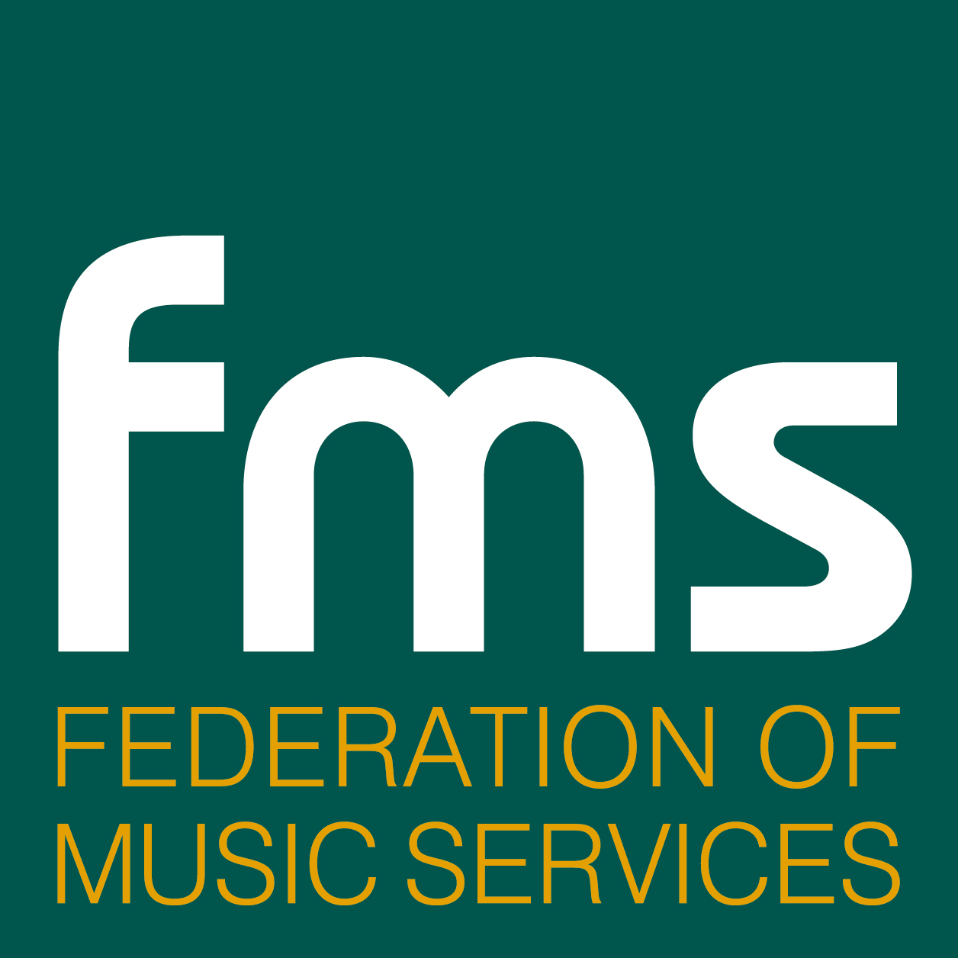

Media Briefing

‘Wow it’s Music Next!’

Research Findings

Introduction to music

Wider Opportunities (WO) has successfully introduced music to children; 96% of primary schools surveyed agreed or strongly agreed that WO has provided instrumental education to those children who would otherwise not receive it.

Figure 3.5.1 – WO provides practical music making to children who would not otherwise receive instrumental education
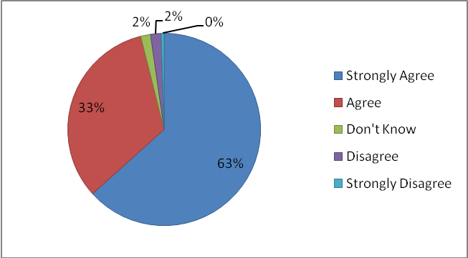
N=971

Music an enjoyable pursuit

The WO programme has been an enjoyable experience for the majority of participating children with 97% of schools agreeing or strongly agreeing – the qualitative and quantitative data suggest high levels of pupil engagement and fun.

4.13.1 – Pupils enjoy WO sessions
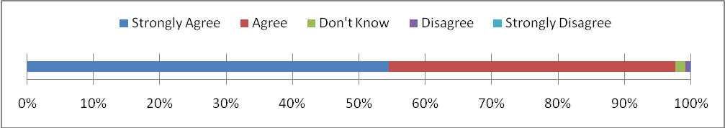N=980

Improved Confidence

There was overwhelming statistical evidence to support the views widely encountered in interview that the children’s confidence had increased with the WO programme (92% with only 2% disagreeing).

Figure 4.1.1 – The WO programme has improved pupil’s confidence
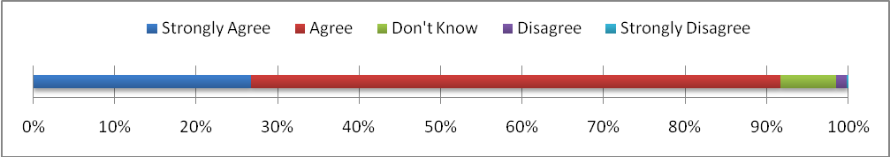N=973

Improved cultural understanding & social development

60% of schools agreed or strongly agreed that the WO has improved pupils’ cultural understanding and 68% agreed or strongly agreed that social development also had been enhanced.

Figure 5.1 – Schools’ comments about their KS2 WO Programme
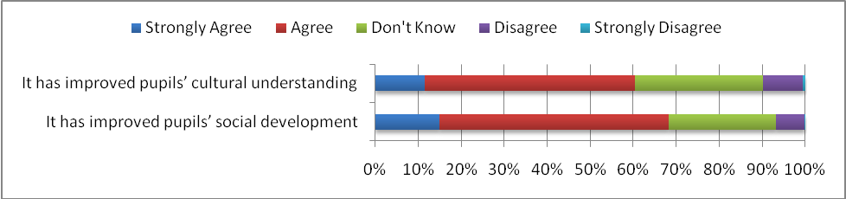N=956

Whole class teaching success

WO is largely delivered through whole class teaching which has proven itself as effective as small group tuition with this age and ability level of children. Instrumental teaching was enhanced through learning in a group as it was deemed les threatening for beginners than individual instrumental lessons.

“It feels more comfortable in the whole class. In whole class when you make a mistake you can pick it up easier.” Pupil

“It’s extraordinary coming from a traditional musical education to see everyone starting off together and interacting together. It’s not about being in a room practicing on your own.” (Music service tutor)

Identified & nurtured talent

Although the focus of WO is on access and opportunity the WO programme had allowed children with talent to be identified and nurtured.

Figure 3.4.2 - WO finds appropriate pathways to progression for pupils with musical talent

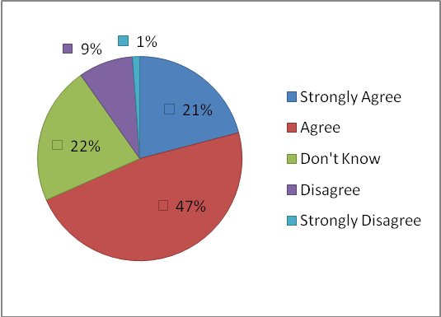
N=951

Spotting talent – 91% of schools agreed or strongly agrees that WO helps identify musical talent and 69% felt that the WO programme met the needs of talented children.

“The Wider Ops programme has revealed talents in the school. We now have 22 children learning the piano.” (Headteacher)

Figure 3.4.3 – School’s statements about the WO programme

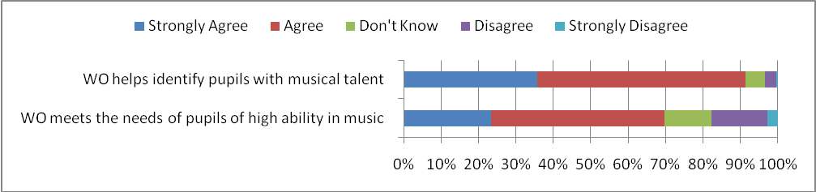N=970

Forged partnerships

WO has helped Music Services forge closer partnerships with local music schools, other providers and musicians. The following figure illustrates the central role that music services play in delivering the WO programme. It was felt that by developing stronger connections with the music industry and specialist schools a greater diversity of programmes could be offered.

Figure 3.2.1 – Partnerships between the schools and other agencies
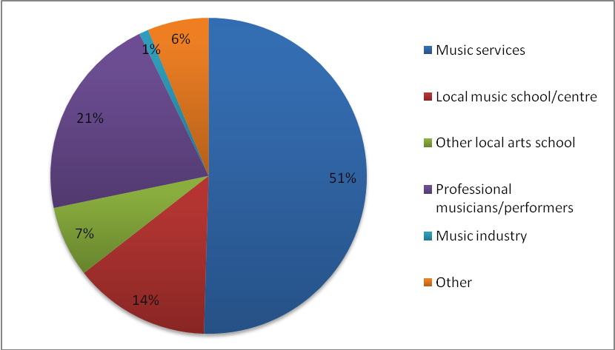
N=988

More training needed for WO teachers

FMS members/specialist music tutors have risen to the challenge of providing quality tuition to many more children; however, class teachers who are not music specialists do need more training in music. It was reported that class teachers were not generally as active in participating in WO lessons as originally envisaged. It was noted that initial teacher education for primary school teachers does not adequately prepare class teachers to feel confident enough to teach music.
“Initial teacher education has to be better. In the PGCE we only did a block of a few weeks. The music professionals can do a lot more than I can in music.” (Class Teacher)
“It is a slow process to get enough teachers to start to feel confident to teach music.” (Class Teacher)

Classroom data

Years 4 & 5 were the most popular for WO. Strings, woodwind, singing, brass and percussion were most frequently taught but in contrast the children's most popular choices were guitar, keyboard and music technology.

- 75% of schools offer additional 'top up' instrumental tuition or support to the WO programme

- The majority of schools have lessons of 45 – 60 minutes a week across the years

Figure 2.4.2 - Which year groups participated in the (WO) programme and in which activities

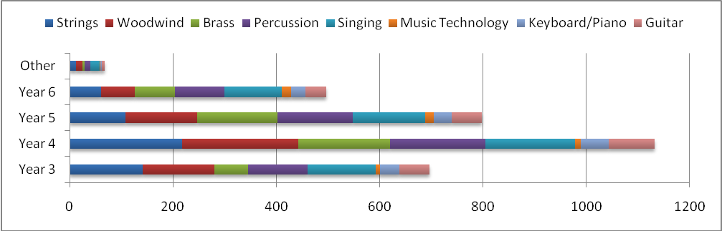

Overall statements about quality

- The WO programme is generally of high international standards
- The programme receives widespread positive support from pupils, parents, teachers, head teachers and local authorities
- There are generally adequate resources for effective, high quality WO
programmes

"It's fun and you learn lots of things" (Pupil)

"I feel excited when I know it's music day. I want to come to school. School is better than staying at home" (Pupil)

Progression

Overwhelmingly, schools acknowledged the benefits of the programme and in the majority of cases wished WO to continue. In particular, it was emphasised that the appropriate resources should exist to promote continuation through to secondary school. The main practical issues identified as inhibiting continuation included pupils' choice, availability of staff and cost.

The continuity of provision beyond the first year, leading to secondary school, needs to be strengthened. Whilst it is recognized that the target of 50% continuation was a challenge, the general consensus expressed in the survey and through visits suggests that other complimentary success indicators were also important.

There was evidence of a positive shift in attitude amongst the school population to music education:

"There's a lot of social deprivation in the school. This has given those you can't financially access the peripatetic option the chance to access instruments. We haven't had a much greater take up of paid for lessons but we have seen a greater enthusiasm for music as a subject."(Music Co-ordinator)

In some cases positive knock-on effects for music in the secondary schools that were being fed by WO primary schools was being seen:

"WO has led to greater take up in the high schools that we feed. They are going in with that basis of experience and that impacts on their take up of peri lessons and of GCSE and A level take up. Because other children have seen their friends performing they have started to express and interest in learning instruments. The percentage has increased enormously since WO started. (Music Service tutor)

The WO Aims and Objectives

There was an interesting divergence of views about the aims of WO - is it simply to teach the instrument or is it a more holistic approach to whole child education? Whole child development and the 'experience of music' score higher in the online survey (fig 2.4.1) but at a quantitative level many teachers expressed the desire for proper instrumental tuition. Some teachers were clear that their purpose was to teach the children the instrument and ensure technical competence and that the children were not developing bad habits. On the other side, others saw the instrument (and voice) as secondary, the main focus being on access, enjoyment and participation.

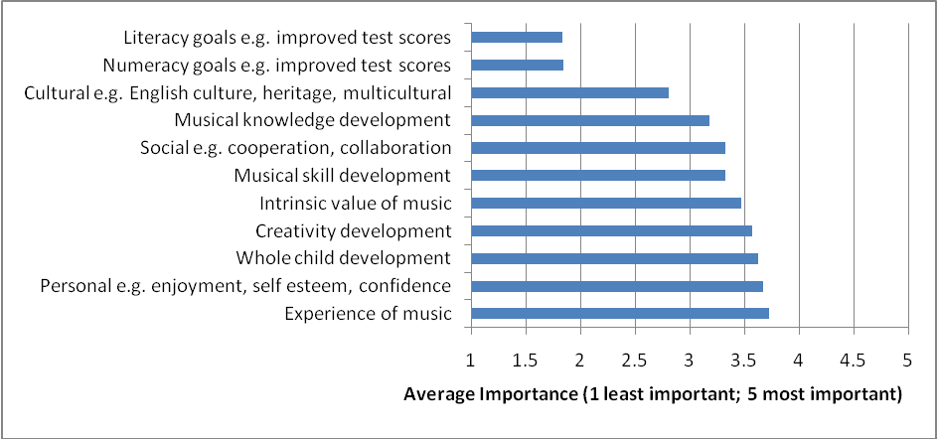
N=969

Future concerns

There were widespread concerns amongst schools and music services that the WO programme may be curtailed in the future if funds are cut from central government and/or local sources.

“I know funding streams from government are difficult at the moment but if this (WO) could be offered to schools every year it would become a regular part of school life and then gradually the impact would build up; it becomes part of the culture of the school.” (Headteacher)

“There are so many new initiatives every year. They don’t give anything a chance to bed in.”(Headteacher)

“Per capita the money available is a reduced amount year on year but at the same time the expectation of what we should be achieving increases.”
(Music Services Manager)

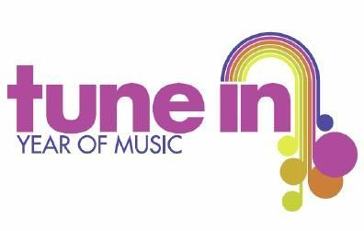

Research background
In March 2009, The Engine Room, a research unit based at the University of the Arts London (UAL), was commissioned by the Federation of Music Services to provide objective evidence about the impact of the Wider Opportunities Programme at Key Stage 2 (WO). This initiative, funded by the Department for Children, Schools and Families (DCSF) through its Standards Fund Music Grant, aimed to provide a year of free instrumental tuition for children in primary schools and widen opportunities through large group/whole class tuition.

The research had three broad aims:
- Evaluate effects and achievements of the WO programme
- Identify good practice
- Make recommendations to improve the implementation of the overall programme

The research, qualitative and quantified, was conducted between March - September 2009 and consisted of:
- 8 Focus Groups with 41 participants including pupils, parents and carers, class teachers and teaching assistants, school music co-ordintaors, head teachers and other senior managers in Key Stage 2 (KS2) schools, specialist music tutors and managers of Music Services
- 56 school visits where 54 WO sessions and performances were witnessed
- 328 interviews with pupils (156 in small groups), 36 teachers and teaching assistants, 48 head teachers and other school managers, 21 school music co-ordinators, 52 specialist music tutors or assistants working on KS2 projects, 15 Music Services' Managers
- There was a further quantified online survey conducted which 1389 schools (21% of the WO schools in the programme)
- 123 Music Services participated in the survey.
Impacts of the WO programme were analysed using the effect and impact tracking matrix (EITM, Bamford 2006) across:

- Pupils and staff
- Schools and Music Services
- Policy and policy development
- Implementation and best practice
- Government aims and aspirations.
ENDS

