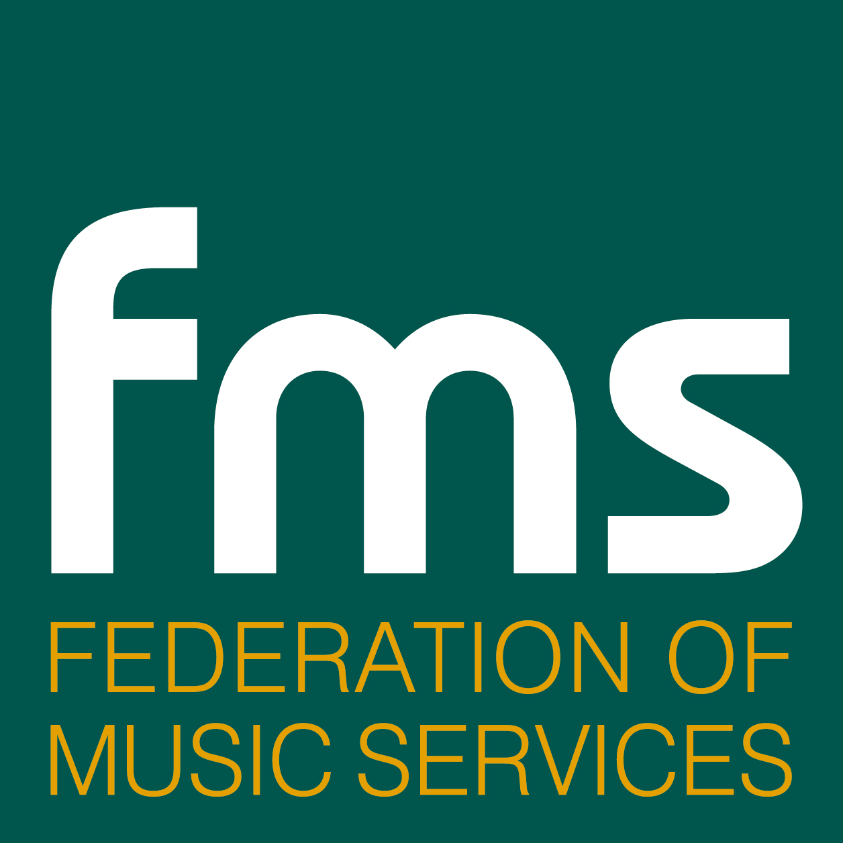

“Wow, it's music next!”*
- A comment from a pupil in the Wider Opportunities programme

Children who learn an instrument at primary school are more confident and have higher self-esteem, according to research into the Wider Opportunities (WO) initiative, where 8 and 9 year-olds learn to play an instrument together as a class for free. They look forward to music lessons and want to do well.

Launched in 2006, this groundbreaking programme will introduce more than two million children to the magic and discipline of making music by 2011. Skilled tutors from local Music Services teach pupils the instrument every week for a year. The class teacher joins in and learns to play too.

Key to the success of WO is broadening access to lessons, giving every child an opportunity to play an instrument, regardless of their parents’ income or interest in music at home. The University of the Arts research released today (29 January 2010) shows that as well as the added benefits of developing children academically and socially, it is a powerful springboard for new talent too.

The research to measure the impact of WO was undertaken on behalf of the Federation of Music Services (FMS) with support from Awards for Young Musicians and the Department for Children Schools and Families (DCSF) which funds the programme. There are over 6500 schools in WO and 1389 participated in the research study.

The key findings are as follows:

- WO is overwhelmingly popular with children; 97% of the primary head teachers and staff surveyed said pupils looked forward to lessons and enjoyed playing and performing;
- 92% of schools said the WO programme has had a very positive effect on children's confidence and self esteem;
- Learning an instrument with all your friends in class has been shown to be as effective as small group tuition for children of this age and ability (Mainly years 4 and 5);
- Strings, woodwind, brass, percussion and singing have been the most popular instruments and activities;
- WO works as a disciplined introduction to learning an instrument, identifying talent and as a joyful experience to benefit ‘whole child’ development;
- Primary school teachers with little or no experience of music tuition have welcomed the opportunity to develop their skills;
- WO music education for children with Special Educational Needs has been outstanding and is exemplary of best international practice.

The survey also revealed that 3 out of 4 schools believe the benefits of WO are so great that they have chosen to invest their own funds, buying in extra programmes over and above those offered free by their local Music Service.

Schools cited many other benefits too including:
- Cultural understanding and social development by pupils are positively affected by the programme
- A more positive attitude to learning and improved motivation in other subjects too
- Team working skills have improved and, in some cases, music provided a calming experience
- Pupils’ concentration has improved
- Music had an empowering effect on some of the participating children

Additional findings included:
- Better progression pathways for music learning in pupils’ later years, particularly when entering secondary school
- Improved teacher development
- More pupil instrument choice and appreciation of music opportunities
- The need for continued financial and resource commitment to schools and Music Services to meet the rapid growth in demand for WO music provisions.

FMS Chief Executive, John Witchell, says the research will be help Music Services develop the WO programme to bring even more benefits to children and schools: “Wider Opportunities has been an extraordinary success! We are now looking at the best ways to support pupils so that they can build on their newly learned skills and progress easily. We also want to support and encourage more class teachers to exploit the many benefits that learning and teaching with Wider Opportunities brings.”

ENDS

Media interviews can be arranged with Anne Bamford (report author), John Witchell, Chief Executive of the FMS, Fionnuala O’Donnell, Headteacher of a WO participating school and Dick Hallam, National Music Participation Director for the DCSF. The report’s findings will be presented by Anne Bamford at the FMS’ Burning Issues conference at 11.10 a.m. on Friday January 29 at RIBA, 66 Portland Place, London.

11am: A WO group of children from a junior school in Haringey will play at the conference. They will be available for filming/pictures; other film and interview opportunities available pre Friday 29 January.

Note to Editors

- The FMS is a registered charity that was formed in the 1990s to help the regional Music Services organisations to be more effective and represent them in dealing with central and local government.

- There are 158 Music Services organisations in England, Wales and Northern Ireland who are members of the FMS (98% of all Music Services). Their role is to provide primary and secondary schools with all that they need to teach music: they set standards, provide teaching aids, equipment and training for heads of music/music teachers. They employ about 10,000 people nationwide and teach over 2 million pupils every year.

- The DCSF support to WO has been through the Music Standards Fund Grant. Widening access at Key Stage 2 (KS2) has been given as a priority for the main baseline grant as well as having a separately identified grant element. This separately identified grant element is formula based and is determined by local authority KS2 pupil numbers with a weighting for disadvantage.

For further information and interviews contact: Douglas Adamson
douglas@watershed-consulting.com Tel: 07860 420763 or 01423 755009
simon@simon-mountford.co.uk Tel: 07836 279685

