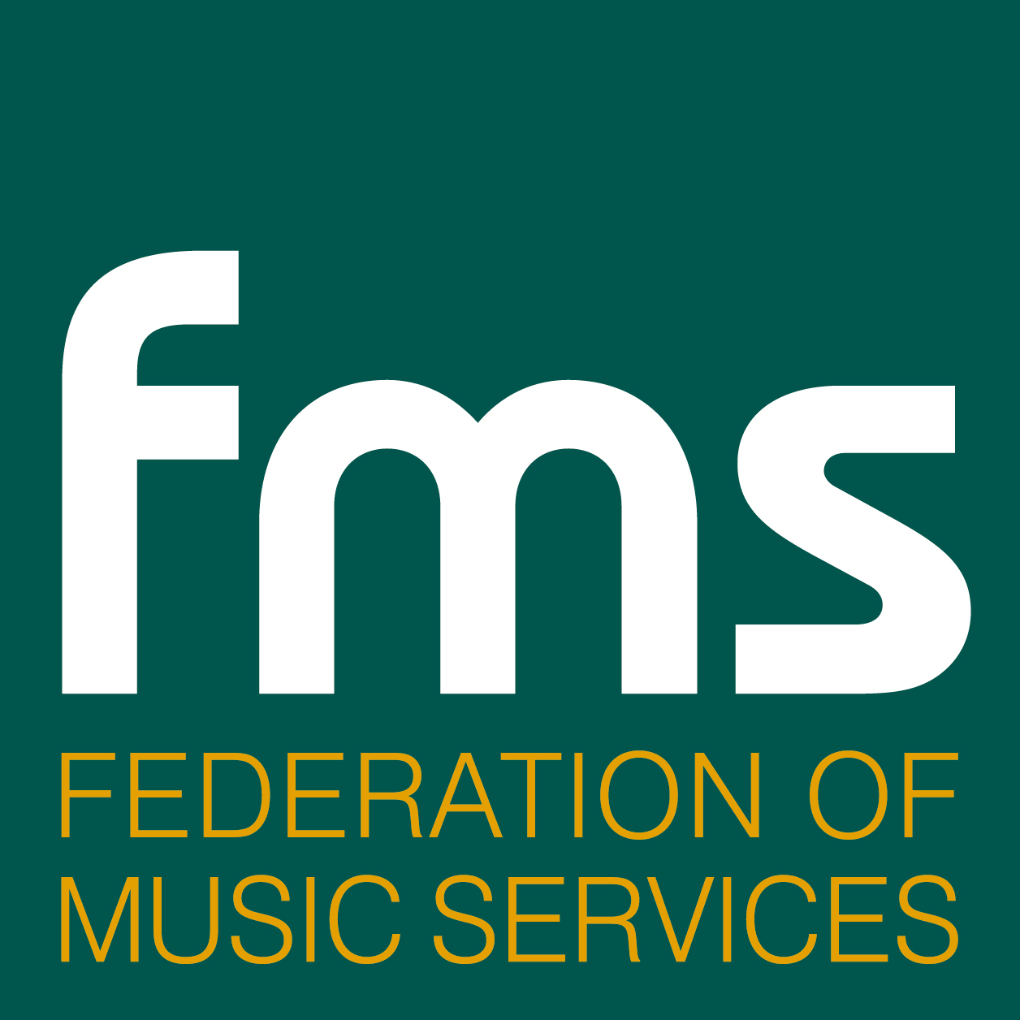

Date: 07 February 2011
Release time: Immediate

The Henley Review and the Government Response:
A Statement from the Federation of Music Services (FMS)

- The annual Music Grant to remain at £82.5m for 2011-12 – no cut
- This award remains protected for music education
- The Department of Education (DfE) and the Department for Culture Media and Sport (DCMS) will work with the Arts Council and other key stakeholders, including the FMS, to prepare a ‘National Plan for Music Education’ to come into effect in 2012 -13
- One of the National Plan’s key priorities will be to ensure that a structure is developed that enshrines the best mix of organisations and services to access funding available at a local level. These services will be identified in the National Plan and will embrace music and wider arts providers.
Virginia Haworth-Galt, Chief Executive of the FMS, said: “I believe this is a landmark report. As music teachers, we see every day the outstanding contribution music makes to a child's development. Darren Henley has argued passionately for the value of music education and has provided clear recommendations to ensure that children, wherever they live in England, can benefit from it.
“We congratulate the Government for responding so positively and listening to the FMS and others across the sector. We welcome the news that Music Services will receive the same level of funding from the Government and hope that this support will continue after 2012. We also urge all local authorities to continue their financial support too.
“By backing the report's recommendation for a 'National Plan for Music Education', the Government has also shown its commitment to work with us, schools and all music educators to make Darren Henley's vision a reality - to provide all children with the music education they deserve.
“This is a huge declaration for music education. We are excited that the FMS’s views on the value of local centres of excellence have been acknowledged. The FMS is looking forward to building on the close relationships we already enjoy with schools and other music partners as we move towards a new era in music and arts provision. To succeed all those involved in music provision must rise to the challenge of working together to deliver a better musical future for our children.”

ENDS

Notes to Editors

- The FMS is a registered charity that was formed in the 1990s to help the regional music services organisations to be more effective and represent them in dealing with central and local government.

- There are 158 Music Services organisations in England, Wales and Northern Ireland who are members of the FMS (98% of all Music Services). Their role is to provide primary and secondary schools with all that they need to teach music: they set standards, provide teaching aids, equipment and training for heads of music/music teachers. They employ about 12,000 music teachers, music tutors and assistants nationwide and teach over 2 million pupils every year. FMS members are the backbone of music education in this country.

For further information and interviews contact:
Virginia.haworth-galt@federationmusic.org.uk
Ms Virginia Haworth-Galt 07827-914323
douglas@watershed-consulting.com
Douglas Adamson 07860 420763 or 01423 755009
simon@simon-mountford.co.uk
Simon Mountford 07836 279685

